Date: 20/04/2026 | Shift: Day: 0700hrs to 1500hrs | Agent: Manasses Munyi

Incidences on critical systems/service
Description | Date/Time | End Date/  Time | Incident  No | Duration | Action to | Status | Incident activities and handover notes | Incident Report  provided
ami down | 18/04/2026@1032hrs |  |  |  |  | Assigned | hufhujvnhrigjoejk
slow system | 18/04/2026@1032hrs |  |  |  |  | Ongoing | call boaz

FIBER INCIDENCES
Incidences | Ref. No | Date & Time  Reported | Duration | Person Assigned | Report Status | Handover Notes
NAIROBI REGION
safaricom  nairobi county bfuijenskj | 23uhg568 | 18/04/2026@1232hrs | 6hrs | eng. ng'eno | Assigned

SYSTEM UPTIME (DAYS)
SYSTEM | UPTIME (DAYS) | LAST DATE OF OUTAGE
AMI | days | 30th september 2025
INCMS | days | 19th april 2026
INSMM | days | 10th april 2026
USSD | days | 10th april 2026
CONTACT CENTRE | days | 10th april 2026
PREPAID | days | 10th april 2026
POSTPAID | days | 10th april 2026
TOKEN TRACKER | days | 10th april 2026
IPMP | days | 10th april 2026
SAP | days | 10th april 2026

SYSTEM SCREENSHOTS
high temp
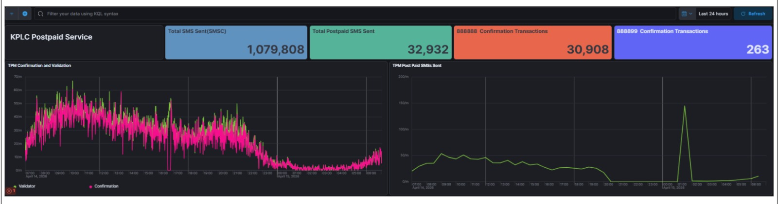

working well
